Mandated Work Placement Program

Project Workflow
(AEN also indicates any supporting GTO)
AEN confirms with the Education Provider the student placement requirements (incl. qualification) and support required.
The host placement provider may require a WWC check, Police check etc. This will be arranged/confirmed by the education provider – TAFE.

AEN seeks new industry host placement providers willing to support VET students to complete their mandatory work placements. (EP may submit contact lists)
It is the responsibility of the TAFE to confirm placement dates, placement agreement forms and any other requirements directly with the student and the host.

AEN completes EOI once host placement provider has committed to take placements. (Refer to EOI Work Flow and EOI status)

When Submitting EOI’s to Placeright we must provide full details of the placement and the TAFE contact person – phone number, email, and Title, in the additional notes section. (Host contact details, how many placements, across what disciplines and who is the TAFE placement coordinator for each course and their contact details)

When submitting EOI to Placeright also send an email to the appropriate TAFE placement coordinator with all the details to follow up. TAFE can be following up the host while they are being set up in Placeright. Ensure the email subject line reads: Confirmed Student Work Placements/ PPA Request.

Do not send TAFE a copy of our EOI form.

Placeright (DHHS) receive the EOI. Placeright will then set up the host provider in the system and send a confirmation to AEN, once the host is set up in Placeright.

Placeright will contact host provider, 24 hrs – 1 wk upon receipt of EOI. Placeright will provide access & training in Placeright training for the Host. Placeright will set up the host record in placeright including – structure and partnership connection and placement schedule. Placeright will notify AEN once this is completed, this will include the host and partnership requested.

Placeright will provide weekly reports to AEN to confirm the status of work placements.

Placeright – work placement status/ stages reported
- Registered
- Confirmed
- Commenced
- Completed

(each team member will be sent a report of their specific placements and registration status)

Once AEN has received confirmation notification from Placeright. AEN will notify the relevant TAFE the of the partnership connection and monitor the progress of the placement.

AEN review Placeright report to ensure Placement/Partnership is on the list and at what stage the partnership is currently at e.g. pending.

If Placement/Partnership is not in the Placeright system
Submit EOI with the status - Not Accepting students in Placeright.

AEN is dependent on the Host Placement Provider and Education Provider to complete the placement. AEN will monitor the placements through Placeright reports and continuous TAFE contact and confirmations.
Due to privacy legalities - all interactions/information regarding the student and the placement can only be provided to the host from the TAFE provider. AEN activity is completed once the placement is registered and confirmed by the Education Provider within the DHHS Placeright system or TAFE placement confirmation reports.
Key:
Industry Host Placement Provider or PP = Host Organisation
Education Provider or EP = TAFE

AEN online EOI portal for host employers

https://aen.org.au/mandatory-work-placement/

Industry Placement Provider employer name
Placement Provider contact details
Placement Provider contact person Name, email, telephone

Qualifications/ discipline available for placement at your organisation
Proposed date range when placement is available with your organisation
How many students are you looking to support during this period

Preferred TAFE
GTO contact

Emailed directly to DHHS Placeright team to set up organisation and login within Placeright – once completed the details are emailed back to the Placement Provider directly

About the DHHS Placeright® platform
https://www.placeright.net.au/About

Placeright is a secure, web-based information system that provides a standard, consistent and secure mechanism for managing student placements between placement providers and their education provider partners. It is funded by the Victorian Department of Health and Human Services and has been developed through close consultation with stakeholders.

Since its release in 2011, Placeright has grown steadily to support over 4,500 users at more than 300 organisations, including all 88 Victorian public health services and 86 education providers across Australia. Placeright aligns with the natural workflow of placement planning, coordination and delivery through a user friendly interface.
Using Placeright can assist organisations providing placements to ensure optimal learning environments for students, meet OH&S obligations, and to inform future staff recruitment.

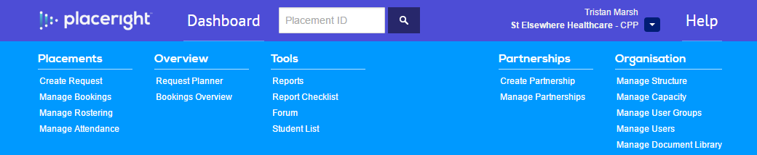
Host Employers – Known as “Placement Providers” in placeright
Partnerships – is where a TAFE and host employer can connect students, dates for work placements

- AEN and DHHS will provide GTO and project support staff with training on the DHHS placeright system.

- DHHS provide host employers and TAFE online helpdesk support and additional training where required.

- AEN will provide weekly/fortnightly progress reports from DHHS placeright data to ensure PGTOs and project support staff can follow up with host employer and TAFE where required.

